|  |  |  |
| --- | --- | --- |
|  | Hyundai Motor America 10550 Talbert Ave., Fountain Valley, CA 92708  TEL: 714-965-3000  MEDIA WEBSITE: HyundaiNews.com  CORPORATE WEBSITE: HyundaiUSA.com |  |
|  | **FOR IMMEDIATE RELEAse** |  |

Contact(s): Derek Joyce Jim Trainor

(714) 594-1728 (714) 594-1629

(714) 376-6653 (714) 316-6421 [djoyce@hmausa.com](mailto:djoyce@hmausa.com) [jtrainor@hmausa.com](mailto:jtrainor@hmausa.com)

**2017 HYUNDAI IONIQ HYBRID AND ELECTRIC MODELS ARE PRICED TO ATTRACT ENTIRELY NEW ECO-FOCUSED BUYERS**

**World’s first dedicated vehicle platform with three electrified  
low-and zero-emission powertrain choices**

**Ioniq Hybrid is the most fuel-efficient vehicle and Ioniq Electric is the most efficient electric vehicle in the U.S. market**

**SANTA BARBARA, Calif., Feb. 14, 2017 –** Hyundai Motor America has provided pricing details for its Ioniq Hybrid and Electric models as it offers its first U.S. media drives in the Santa Barbara region of California. The Ioniq is the first vehicle in the world to offer three distinct electrified powertrains on a single, dedicated vehicle platform. Hyundai’s approach for the Ioniq line delivers an uncompromising design and driving experience coupled with the latest in safety and convenience technologies, making it an appealing choice for a wide range of buyers. The Hyundai Ioniq is an important milestone in Hyundai’s global sustainability strategy.

**2017 HYUNDAI IONIQ HYBRID PRICING**

|  |  |  |  |  |
| --- | --- | --- | --- | --- |
| **Model** | **Engine** | **Transmission** | **Drivetrain** | **MSRP** |
| Blue | 1.6L GDI 4-Cylinder | 6-Speed EcoShift Dual Clutch Transmission w/ SHIFTRONIC® | FWD | $22,200 |
| SEL | 1.6L GDI 4-Cylinder | 6-Speed EcoShift Dual Clutch Transmission w/ SHIFTRONIC® | FWD | $23,950 |
| Limited | 1.6L GDI 4-Cylinder | 6-Speed EcoShift Dual Clutch Transmission w/ SHIFTRONIC® | FWD | $27,500 |

Freight Charges for the 2017MY Ioniq Hybrid are $835.

**2017 HYUNDAI IONIQ ELECTRIC PRICING**

|  |  |  |  |  |
| --- | --- | --- | --- | --- |
| **Model** | **Engine** | **Transmission** | **Drivetrain** | **MSRP** |
| Electric | 88kW Electric Motor | Single-speed Reduction Gear | FWD | $29,500 |
| Limited | 88kW Electric Motor | Single-speed Reduction Gear | FWD | $32,500 |

Freight Charges for the 2017MY Ioniq Electric are $835.

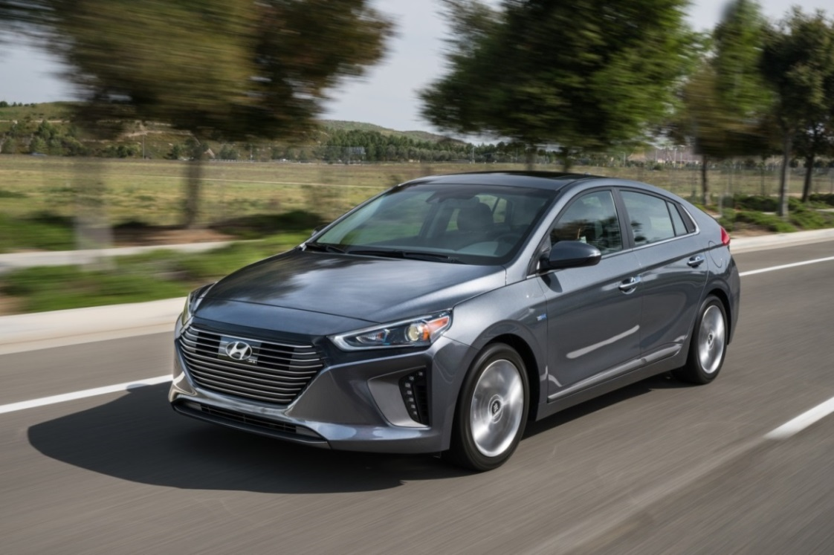

“Ioniq will attract an entirely new group of eco- and efficiency-oriented buyers in the U.S. market,” said Mike O’Brien, vice president of Corporate and Product Planning, Hyundai Motor America. “With outstanding powertrain flexibility, design, connectivity, and advanced technologies, Ioniq meets the needs of a large and growing group of buyers needing a highly efficient, enjoyable to drive and low-emissions vehicle without compromise to their daily lifestyles.”

**HYUNDAI MOTOR AMERICA**

Hyundai Motor America, headquartered in Fountain Valley, Calif., is a subsidiary of Hyundai Motor Co. of Korea. Hyundai vehicles are distributed throughout the United States by Hyundai Motor America and are sold and serviced through more than 830 dealerships nationwide. All Hyundai vehicles sold in the U.S. are covered by the Hyundai Assurance program, which includes the 5-year/60,000-mile fully transferable new vehicle limited warranty, Hyundai’s 10-year/100,000-mile powertrain limited warranty and five years of complimentary Roadside Assistance. Hyundai Blue Link Connected Care provides owners of Hyundai models equipped with the Blue Link telematics system with proactive safety and car care services complimentary for one year with enrollment. These services include Automatic Collision Notification, Enhanced Roadside Assistance, Vehicle Diagnostic Alert, Monthly Vehicle Health Report and in-vehicle service scheduling.

For more details on Hyundai Assurance, please visit [www.HyundaiAssurance.com](http://www.hyundaiassurance.com/)

Please visit our media website at [www.hyundainews.com](http://www.hyundainews.com) and our blog at [www.hyundailikesunday.com](http://www.hyundailikesunday.com)

Hyundai Motor America on [Twitter](http://twitter.com/hyundai) | [YouTube](http://www.youtube.com/hyundai) | [Facebook](http://www.facebook.com/Hyundai)